**Year 11 ATAR Chemistry**

Practical Assessment – Validation Test

Firework colours and Flame Tests

NAME: ________________________ TEACHER: ________________________

MARKS: _____ /32

**Instructions:**

* You have 35 minutes to complete this assessment.
* You will be provided with the ATAR Chemistry Data book.
* Please answer the questions in the space provided.

**Questions:**

1. List the independent and dependent variables for this experiment. (2 marks)

|  |
| --- |
|  |
|  |
|  |

1. Identify three variables that needed to be controlled in this experiment. (3 marks)

|  |
| --- |
|  |
|  |
|  |

1. What colours were visible when the following ions were present in the flame? (4 marks)

|  |  |
| --- | --- |
| Ion: | Colour exhibited: |
| Barium (Ba2+) |  |
| Calcium (Ca2+) |  |
| Potassium (K+) |  |
| Strontium (Sr2+) |  |

1. Explain why this experiment is called a ‘qualitative analysis’. (1 mark)

|  |
| --- |
|  |
|  |
|  |
|  |

1. Draw the electron structure and write the electron configuration for the following elements:

|  |  |  |
| --- | --- | --- |
| **SODIUM** | **MAGNESIUM** | **CHLORINE** |
| Electron structure: | Electron structure: | Electron structure: |
|  |  |  |
| Electron configuration: | Electron configuration: | Electron configuration: |
|  |  |  |

(6 marks)

1. What are the comparisons that can be made between this basic experiment and the Atomic Absorption Spectrometry analysis covered in class. (3 marks)

|  |
| --- |
|  |
|  |
|  |
|  |
|  |
|  |
|  |
|  |
|  |

1. Describe what occurs when an atom absorbs visible light and use a diagram to illustrate your answer.

(4 marks)

|  |  |
| --- | --- |
|  |  |
|  |
|  |
|  |
|  |
|  |
|  |
|  |

1. Describe what occurs when an atom emits visible light and use a diagram to illustrate your answer.

(4 marks)

|  |  |
| --- | --- |
|  |  |
|  |
|  |
|  |
|  |
|  |
|  |
|  |
|  |  |

1. The following diagram is a representation of the electromagnetic spectrum. Estimate the wavelength range of the light emitted by atoms of the listed elements. (5 marks)

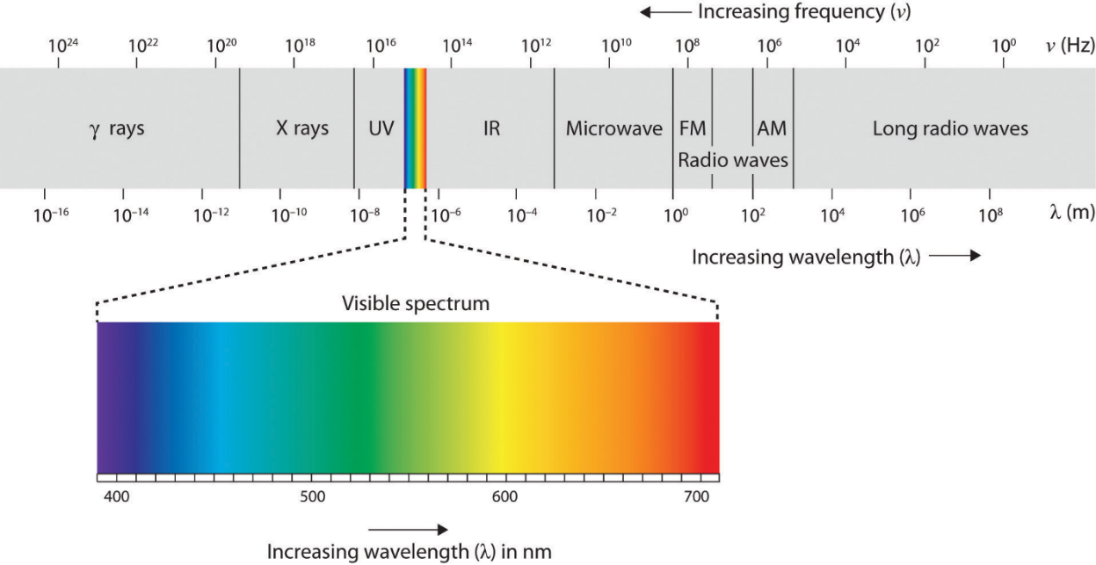

|  |  |
| --- | --- |
| **Element:** | **Approximate emitted wavelength range (nm)** |
| Strontium |  |
| Calcium |  |
| Potassium |  |
| Sodium |  |
| Copper |  |

End of Validation Test